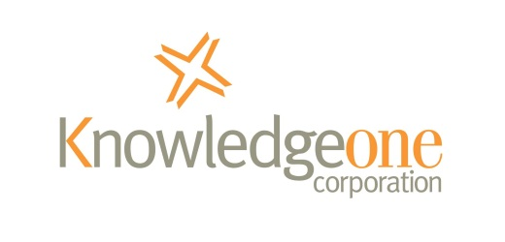

RecFind 6 Button Survey
The following simple survey should take no more than a minute or two to complete.
The completed survey will be analysed by one of our document management consultants and you will receive a set of recommendations on how you could best utilize the RecFind 6 Button based on your requirements.
You will note that you can also ask questions specific to your needs at the end of the survey.
Your full name
Your organization
Your email address
Your phone number

1 | What types of documents do you need to capture? (Please click box to select it)
 |  | Word
 |  | Excel
 |  | PowerPoint
 |  | Outlook
 |  | Adobe PDF
 |  | Web Pages/URLs
 |  | Lotus Notes
 |  | GroupWise
 |  | Other, Please list below

2 | How many of your staff will need to use the Button?
3 | How many different security codes will you need?  For example, Directors, Managers, Staff, Contractors. This is to ensure controlled access to captured documents.
4 | How many different classifications will you need?  For example, Human Resources, Purchasing, Accounting, Engineering, etc. Keep it simple so as to make it as easy as possible for staff to save and retrieve documents.
5 | Do you need to initiate workflow when you save a new document?  For example, to initiate a series of tasks to generate a response.
6 | If yes to above, approximately how many workflows will you need?
7 | Will you use the Button for document scanning?  The button connects to any TWAIN scanner and as well as scanning, can also OCR the scanned document and produce a searchable PDF for storing in RecFind 6 a much more useful format than a TIFF file.

Questions specific to your needs:
Q1
Q2
Q3
Please email to: sales@knowledgeonecorp.com

